Definite Article

📘 Types of Article Determiners – Definite Article
# Source: AI Source: Provided by: [Data Path: Persons Table -> ID Column: 1, Name_En Column: Motasem Essam] -> From: [Chatgpt (GPT-4-turbo)] on [7/28/2025]
The definite article in English is:
✅ "The"

🔍 What is a Definite Article?
# Source: AI Source: Provided by: [Data Path: Persons Table -> ID Column: 1, Name_En Column: Motasem Essam] -> From: [Chatgpt (GPT-4-turbo)] on [7/28/2025]
A definite article is used to refer to a specific person, place, thing, or idea that is already known to the speaker and the listener.

✅ Examples of “the” in Sentences:
# Source: AI Source: Provided by: [Data Path: Persons Table -> ID Column: 1, Name_En Column: Motasem Essam] -> From: [Chatgpt (GPT-4-turbo)] on [7/28/2025]
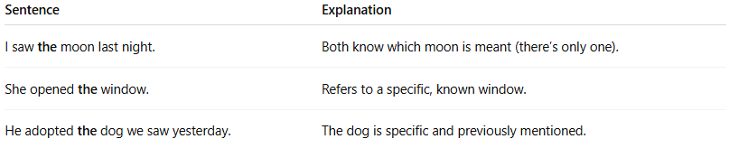
Sentence | Explanation
I saw the moon last night. | Both know which moon is meant (there’s only one).
She opened the window. | Refers to a specific, known window.
He adopted the dog we saw yesterday. | The dog is specific and previously mentioned.

📌 When to Use "The":
# Source: AI Source: Provided by: [Data Path: Persons Table -> ID Column: 1, Name_En Column: Motasem Essam] -> From: [Chatgpt (GPT-4-turbo)] on [7/28/2025]
- When the noun is unique or specific.
- When the noun has been mentioned before.
- When there is only one (e.g., the sun, the president).
- When using superlatives (e.g., the best, the tallest).

🛑 Don't Use "The" When:
# Source: AI Source: Provided by: [Data Path: Persons Table -> ID Column: 1, Name_En Column: Motasem Essam] -> From: [Chatgpt (GPT-4-turbo)] on [7/28/2025]
- Talking about general ideas (e.g., "Cats are cute.").
- With most proper nouns (e.g., "I live in Egypt." not "the Egypt").

